Associated Papers for the meeting on 15th October 2024
Agenda item
1 Apologies for absence
2 Declarations of interest and requests for dispensation from Councillors
If there is an item on this agenda for which you have a pecuniary interest you will not be able to take part in any of the discussion or vote on a resolution. However, if you wish the council to consider your request for dispensation you will need to write to the clerk ahead of the meeting stating your reasons on why you should be given a dispensation, or to raise the item now.
.4 County and District Councillor reports
Current news from both BDC and SCC can be found via the following links:
News » Babergh Mid Suffolk, Council news - Suffolk County Council
5 Planning

c Status of Planning applications
Householder Application - Erection of single storey rear and first floor side extensions including re-roofing conservatory.58 Ash Road Onehouse Stowmarket Suffolk IP14 3HB
Application. No: DC/24/02697 Status: Granted
DC/24/03772 105 Northfield Road Onehouse Stowmarket Suffolk IP14 3HE Awaiting Decision
6 Routine Correspondence.
If you wish to discuss an email forwarded that does not appear on the agenda please raise at this point.
There have been a variety of correspondence including:
News letters re
- Public Sector executive
- What’s New in Public Sector Today
- Village Halls and community buildings
- Suffolk Waste Partnership
- SALC local councillor magazine
SALC various updates including training, vacancies
National Grid update
- Insurance renewal Zurich Municipal
- Suffolk Highways update on the footpath it legal stuff should be underway soon they will revert when they have more info
7. Clerk’s Report
Consider draft policies with a view to adopting them
Actions from previous meeting
Minute no | Action | Who | Resolved
24/7/8 | Ask SCC about passing places in Starhouse Lane | Clerk
24/7/16 | Contact Realise Futures to produce laminated sign for Forest Road Noticeboard | Clerk
24/7/19 | Items for future meetings, Clerk recruitment, Onehouse Meadow update, Chilton Leys footpath | Clerk
Monthly | Planning application responses to MSDC | Clerk
Monthly | Pay creditors | DB & JC
24/9/ | Contact vendors to notify of website change | Clerk
24/9/4 | Formally complain to Woodland Trust re Deer Management | RL
24/9/4 | Investigate Hedge encroachment on footpaths and report back | RL
24/9/10 | Short list applications for clerk role and organize interviews | JC, DB, IC
24/9/11 | Purchase mobile phone and sim card for use by new clerk | ?
24/9/12 | Purchase Eco benches 1 for Paupers Graves 2 for community centre and 1 picnic bench for playing field | ?
24/9/14 | Audit training and investigate with Cllrs what training is required | Clerk | ongoing
24/9/15 | Oktoberfest advertising and ticket sales | Working party
24/9/15 | Village Show, book hall and playing field | RL
24/9/16 | Contact SCC Highways and CC CCllr Otton | Clerk
24/9/17 | Cllrs Leek and Boulter to liaise, Clerk to pursue contacts with TW | DB,RL, Clerk

8 Finance Report
Consider £12 increase in hall hire to accommodate wifi in the building
Review the external auditor report

Current account currently stands at £5,470.59
Deposit account £36,103.21

Income
£48.28 interest
£533.92 OHSMAG advertising
£100 Oktoberfest
Payments to be made
£1,150 Temporary Clerk
£321.71 Glasdon – dog bin
£396.00 Zurich insurance
£300 J R Landscapes
£392.00 Gipping Press
£120.94 OHSMAG editing
£252.00 PKF Littlejohn
£? Expenses for Oktoberfest
£20 training – Wildlife in the community
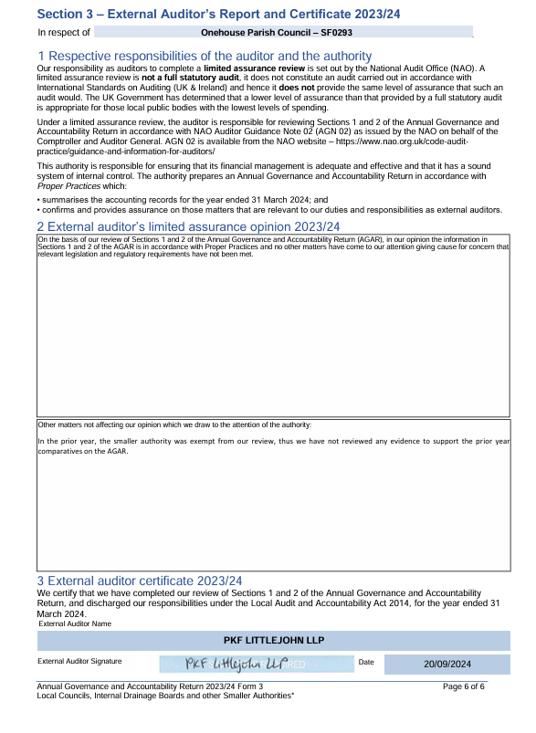

9 Licenced paths, footpaths and assets
- Proposal: to obtain quote for tree coppicing. (Jo C & John C)
Background:
The trees in the Paupers Graves have been maintained by local tree surgeon Neil Green for many years. Neil provides wood chippings free of charge to the site every year before the rainy season and inspects the trees when visiting. On a recent visit delivering wood chippings Neil mentioned that the trees are now coming up on the cycle for coppicing in January 2025, and has also pointed out some dead branches quite high that need removal.
- proposal: requesting the trees on the village green on Forest Road and grass verge on Northfield Road are cut back by SCC. (Jo C)
Background:
Both sets of trees are causing issues with dropped fruit and acorns onto public footpaths, and in Northfield Road have grown over into private gardens. If SCC will permit coppicing the trees, but not fund it, OPC will obtain quotes for the work with a view to funding it. Cllr Otton has provided Harleston money from her locality budget for this type of work in the past, and the potential need for this work was why we hadn’t agreed to apply for money from SCC for the stretch on Forest Road to be cut back outside of the Onehouse boundary.

10 Recruitment and HR matters
Clerk interview held on 10 October 2024
  - Proposal purchase a copy of Arnold Baker book for use of new Onehouse clerk (Jo C & CH) £190 Lexis Nexis
  - Set pre-arranged annual contract fee for ground maintenance work
  - Set pre-arranged annual contract fee for OHSMag editing
Background: Both intended to improve minimum budget setting going forward, with the expectation that additional costs may be required across the year and will be billed for separately.

Purchase of mobile phone and sim card
  - purchase of mobile phone for new clerk (Jo C)
A mobile phone with internet connectivity and camera with good recommendations Cllr Copping has researched both specification and reviews of phones meeting this brief and recommends the Honor X7b.
Listed are three alternative vendors of this model phone, all chosen as they have the option to easily return the phone for repair if needed. Cost is £129.99 at all three providers
Argos - SIM Free HONOR X7b 128GB Mobile Phone - Midnight Black (argos.co.uk) £129.99
Currys - Buy HONOR X7b - 128 GB, Midnight Black | Currys £129.99
Carphone Warehouse - HONOR X7B Contract & SIM Free Deals | Carphone Warehouse £129.99
Pay as you go sim cards
Smarty sim £5 for 5gb
Giff Gaff £8 4gb
If approved decision needed on who will make the purchase.

11 Community Centre
- Proposal: requested to lease a storage unit from the Community Centre. (Jo C & DB)
Background: We have several items that belong to the parish and were in use by the clerk such as filing cabinet, shredder, and printer. These could be stored until needed or disposed of. With events now being organised by the council, it would also be prudent to have a place to store items in preparation for events or required for re-use. It would also provide a facility for storing items when not in use such as batteries for the speed signs. There are empty units available, so permission is sought to request pricing for discussion at the next meeting.
12 Events
- Receive events update
  - Oktoberfest feedback (Jo C DR & DB)
  - Village show progress (RL)
  - Suggestion of combined village event at Harleston Green in 2025, proposed by Shelland chair
- Proposal:
  - 2025 Burns night event (IC)
  - 2025 Oktoberfest (Jo C)
13 OHSMAG
- Proposal reducing council updates in OHSMag to just one page each (Jo C)
Background: The OHSMag is becoming too heavy on council information. The input from Onehouse has previously been excessively long and taken up a lot of space.
We have recently received a complaint from the editor relating to the content of the submitted minutes and commented that the magazine should not be a stage to ‘tell people off’, specifically the placement of items for sale in public spaces.
The information from Onehouse Parish council is available on the noticeboard and on the website, so there is no expectation a summary of the minutes is included. If a member of the public specifically requests minutes from the clerk this could be provided via email, or they can be pointed towards the noticeboard.
- Proposal: approve change of OHSMag committee to a working group (Jo C)
Background: The committee was set up many years ago and was paused for some time with no meetings being held, the editor at that time being on the OPC. The meetings were reinstated after the editor ceased to be a councillor. The meeting attendees have grown to include residents of both Harleston and Shelland, as well as the latest editor. As the group is not now solely OPC councillors it is not appropriate to hold the meetings as a committee but can continue with current members as a working group. This change will also reduce some of the administrative work required, with official agendas and minutes not needing to be publicly displayed.
The working group would not require specific terms of reference but will continue to provide updates and make recommendations to the council for discussion and approval where appropriate.

End of Associated Papers

